Speaker/Panelist Bios
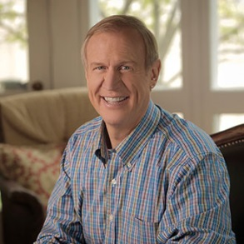
Bruce Rauner
42nd Governor of Illinois

Bruce Rauner (Republican) was sworn in as the 42nd Governor of Illinois on Jan. 12, 2015.
His goal as governor is to create a more prosperous state, where everyone has an opportunity to succeed. Bruce will remain focused on delivering value for taxpayers, creating a pro-jobs economic climate, ensuring world-class schools and educational options for every Illinoisan, and bringing term limits and greater accountability to state government.

Bruce was born in Illinois and is a self-made businessman who had no inheritance or family wealth.
A dedicated and diligent student, Bruce worked while he attended Dartmouth College, where he graduated with top honors. He went on to earn an M.B.A. from Harvard.

Returning to Illinois in 1981, Bruce began working at then startup investment company Golder, Thoma, Cressey (later GTCR). As one of its earliest partners, Bruce helped build the firm into one of the most successful and respected businesses in Illinois.

Bruce has reinvested much of his success into the state he loves through supporting education, the YMCA, local hospitals and community organizations. His greatest passion is education. Bruce and his wife, Diana, have devoted a tremendous amount of their personal time and resources to improving education throughout the state.

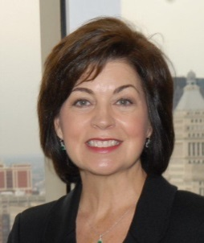
Theresa E. Mintle
President & CEO
Chicagoland Chamber of Commerce

Theresa E. Mintle is the fifth president and CEO of the 110 year-old Chicagoland Chamber of Commerce. As the influential voice for businesses of all sizes and industry, the Chamber helps grow our regional economy and strengthen Chicago’s status as a world-class city. Theresa leads the Chamber’s strategic focus on small business growth, international expansion, technology innovation and regional collaboration. Active in Chicago’s business and civic community, Theresa is on the board of Choose Chicago; a director of the World Business Chicago Steering Committee; the President’s Circle of the Chicago Council on Global Affairs; a member of The Economic Club of Chicago; and an executive committee member of FARM Illinois.
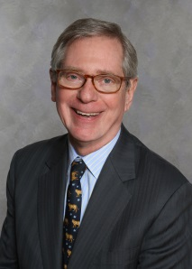
Thomas A. Stewart
Executive Director
National Center for the Middle Market

Thomas A. Stewart is the Executive Director of the National Center for the Middle Market, the leading source for knowledge, leadership and research on midsized companies, based at the Fisher College of Business at the Ohio State University.
Before joining the National Center for the Middle Market, Stewart served as Chief Marketing and Knowledge Officer for international consulting firm Booz& Company (now called Strategy&). Prior to that, he was for six years the Editor and Managing Director of Harvard Business Review, leading it to multiple finalist nominations for a National Magazine Award. He earlier served as the editorial director of magazine and as a member of Fortune’s Board of Editors.
A twelve-time participant in the World Economic Forum, he is the author of two books, Intellectual Capital: The New Wealth of Organizations and The Wealth of Knowledge: Intellectual Capital and the Twenty-first Century Organization, published by Doubleday Currency in 1998 and 2003, respectively.
Stewart is a summa cum laude graduate of Harvard College and holds an honorary Doctor of Science degree from Cass Business School, City University London.

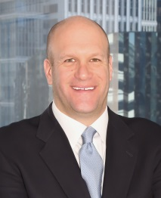
Tom Gimble
Founder & CEO
LaSalle Network

Tom Gimbel is the Founder and CEO of LaSalle Network, a Chicago-based staffing and recruiting firm.
For the past five years (2011-2015), Staffing Industry Analysts has named LaSalle Network one of the top five Best Staffing Firms to Work for in the country, and recognized LaSalle Network on its national list of Fastest-Growing Staffing Firms for the past three years (2012-2014). Also, LaSalle has been named to the Inc. 500/5000 list of Fastest-Growing Private Companies in America for the past eight consecutive years (2007-2014), and Crain’s Chicago Business’ list of Best Places to Work in 2014 and 2015.
Gimbel is a nationally recognized career and workplace expert and entrepreneur with major awards and acknowledgments, including being named by Entrepreneur magazine as 1 of 10 Up-and-Coming Leaders to Watch in its March 2014 issue.
Gimbel holds a bachelor’s degree from the University of Colorado and is on the Board of Directors of Ounce of Prevention, and is also involved with Young Presidents’ Organization, American Staffing Association, and an active member of Economic Club of Chicago, Human Resources Management Association of Chicago (HRMAC), and the Society for Human Resource Management (SHRM).

Jenny Niemann
CEO
Forward Space

Jenny is the CEO and majority owner of Forward Space. The company provides leading organizations with advanced spaces and environments to meet their business goals. Forward Space offers workplace consultation, planning, procurement, delivery and installation and on-going maintenance to support client vision and goals for tomorrow. The company is proud to represent and sell Steelcase Products.

Prior to becoming the Forward Space owner, Jenny was CEO of Red Thread, a Steelcase Dealership in New England. Jenny started her career with Accenture (Andersen Consulting) in information systems consulting. She then spent nearly 20 years with Steelcase before moving to Red Thread. Her work experience has been focused in sales, product innovation and process improvement through Information technology and LEAN methodologies.

Jenny graduated with honors from the University of Michigan with a MBA in 1996. In 1990, she graduated Cum Laude from Bowdoin College, in Maine with a double major in Mathematics and Economics.

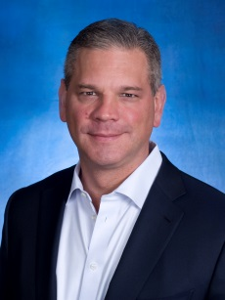
Trevor Schauenberg
President & CEO
GE Capital, Corporate Finance

Trevor A. Schauenberg is president and chief executive officer of the Americas Direct Segment within GE Capital. The segment combines direct lending and leasing expertise from across Capital including the Corporate Finance, Fleet Services and Rail Services businesses. He also oversees direct lending and leasing in Canada and Mexico. He was appointed to his current role in 2014.
Prior to this, Trevor was Vice President of Corporate Investor Communications for GE since 2008. He served as Vice President and Chief Financial Officer (CFO) for GE Capital Solutions starting in 2006, when he was also named a GE company officer.
Before joining GE Capital Solutions, Trevor was CFO for GE Infrastructure, Transportation starting in 2003. He was appointed CFO for GE Insurance Solutions Global Property and Casualty Reinsurance based in Germany in 2001, and CFO for Insurance Holdings within GE Commercial Finance in London beginning in 1999.
Trevor was a member of GE’s Corporate Audit Staff for six years, becoming executive audit manager for GE Capital in 1997. He joined the Financial Management Program at GE Healthcare in 1991, after receiving a Bachelor’s degree in Finance from the University of Iowa that same year.
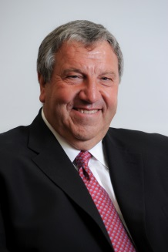
Giancarlo Turano
Principal
Turano Baking

Giancarlo Turano is a Principal of Turano Baking Company, Managing Director of Turano Florida Bun, Knead Dough Baking and Turano Georgia Bread. His responsibilities are all encompassing Sales, Distribution, Purchasing and Business Development.
Giancarlo is an active member of the executive committee of the Big Shoulders Fund (BSF), an organization that raises funds for inner-city children seeking a quality education in Chicago. He has served as the Co-Chair for the BSF Annual Golf Classic raising over $5,000,000 in scholarships over several years. He sits on the Loyola University Rome Center Advisory Committee. He has twice served as Campaign Manager for Renato Turano, the current Senator to the Republic of Italy representing the North and Central American region.
In addition, Giancarlo is a board member of Casa Italia, the Italian Cultural Center. The Center promotes interest in Italian Culture, Experience, and Language, as well as Italian language education for young and old.
Giancarlo Turano is a graduate of Loyola University Chicago and holds a Bachelor’s degree in Business Administration and Accounting.

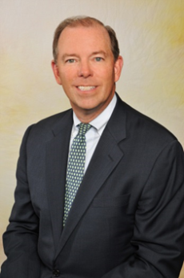
John Martin
Global Head, Capital Markets
GE Capital

John Martin is the leader of the Global GE Capital Markets COE. GE Capital syndicates, sells and securitizes transactions and portfolios originated by all of the GE Capital businesses to institutional investors, banks and finance companies around the world.
Most recently, John was the President and Chief Executive Officer for GE Antares, which provides acquisition financing to the Private Equity Sponsor community. In 1996, John was a co-Founder of Antares Capital Corporation, a Chicago-based provider of acquisition financing. He became Chief Operating Officer of Antares in 2000.
Prior to forming Antares, John was a senior executive with Heller Financial, a Chicago-based commercial finance company. He began his career with Continental Illinois National Bank.
He earned his BBA-Finance from Notre Dame in 1982. John is on the Business Advisory Council for the Mendoza College of Business at the University of Notre Dame. He is also a member of the Economic Club of Chicago, Executive Club of Chicago, and a board member of numerous non-profit organizations.

